Socket Programming –A simple file server
Vinaydeep Singh
CSC563 Multithreaded Distributed Programming
Masters in Computer Science. Software Developement
New Haven, Connecticut
singhv4@southernct.edu

Abstract— This project will show us how to use socket programming to create a simple centralized file sharing system. We grasp the design principles of a centralized file sharing system and complete the program provided by the instructor for this assignment.

Introduction

The Internet has clearly become the 'Soul of Existence,' with 'Connections' or 'Networks' defining its activities. One of the most important principles of Sockets is used to enable these networks. Sockets assist in making these connections, and Python, without a doubt, makes it easier. Socket programming is a method of allowing two network nodes to communicate with one another. One socket (node) listens on a specific port at an IP address, while the other socket establishes a connection with it. While the client connects to the server, the server creates the listener socket.
They are the true foundations of online browsing. There is a server and a client, to put it in simple terms.

design and implementation
Sockets (also known as socket programming) is a program that allows two sockets to communicate bi-directionally at any time. It is an excellent alternative for constructing a variety of apps because it works by connecting two sockets (or nodes) and allowing them to communicate in real time.
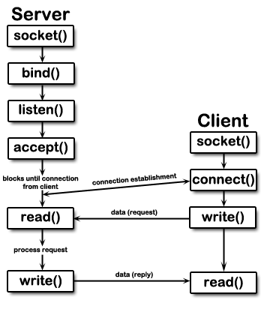
For our Implementation of socket programming, we are using 6 files. Namely:
- Server.conf
- Client.config
- Config.py
- Protocols.py
- Client.py
- Server.py

- In the server configuration file, we mention 2 things: the Server port number and the folder associated with the Server side of our program.
- In the client configuration file , we see a server location, server port address for communication, a client port address, and the folder path for the client side.
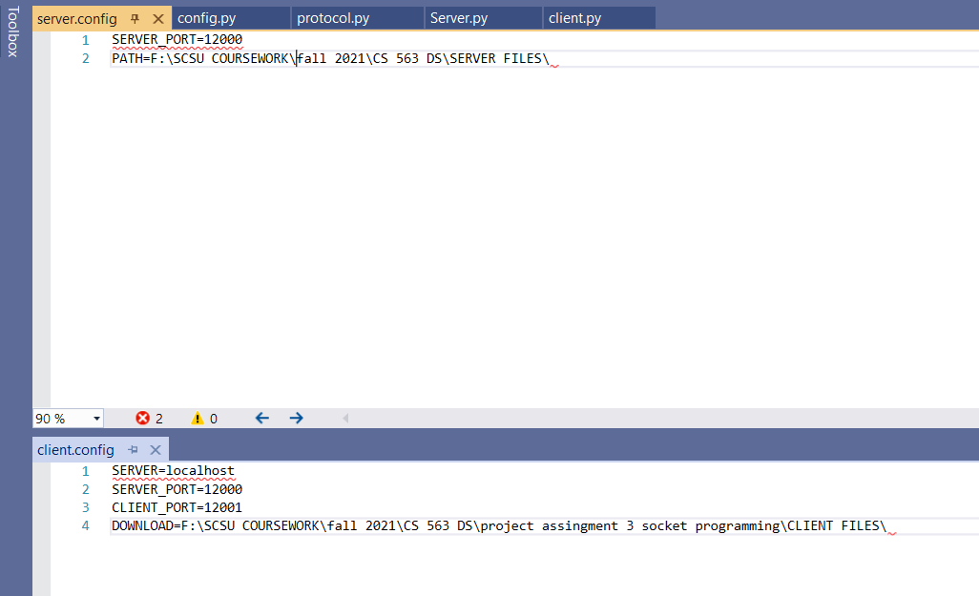
- The config.py file contains a class which has a function to read the server.config file and returns 2 variables serverport and serverpath. Similarly, it also has a function to read the client.config file and returns 4 variables mainly servername, serverport,clientport and clientfolder.there is also a function to test the functionalities of the server and client side configuration.
- The protocol.py file has variables which define the protocol being used in the communication. Some of them being download, upload, request file, error.
We prepare the messages that are sent between server and client as Header + msg. we have functions to encode and decode the message during communication. We also have a function to encode the list returned to the client side during downloading a file from the server functionality.
- Next up we have the Server.py file. We should Note that in order for our program to run properly, the server.py script should be the first to be run and that all other files should be in the same directory. Inside the server file we have a constructor to load in the server.config file. We have many functions in this main server file. A getFileList function takes returns another function list directory from the self.path mentioned in the server.config file. When the client requests to download a file a socket is created and the server sends the file list and asks for the file number it wishes to download. It has a function sendFile() sends files in packets of 1024 bytes through the socket connection.
Similarly, it has a recieveFile() function that receives the file in parts of 1024 bytes and then writes them onto the drive.
We have Start() function which is the main function of our program. It defines a port and a socket which binds to that port number and then starts listening on that port.

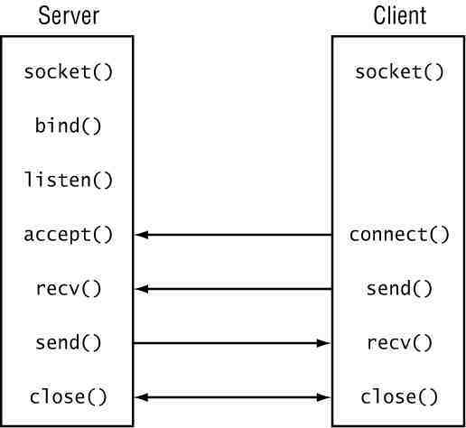

Then we have functionalities of the start functions which caters to different requests from the client such as displaying files, downloading, and uploading files.
- The client file is pretty straightforward. It has a constructor which loads information from the client.config file. It has a function to display A menu of options which goes on until the user exits the program.
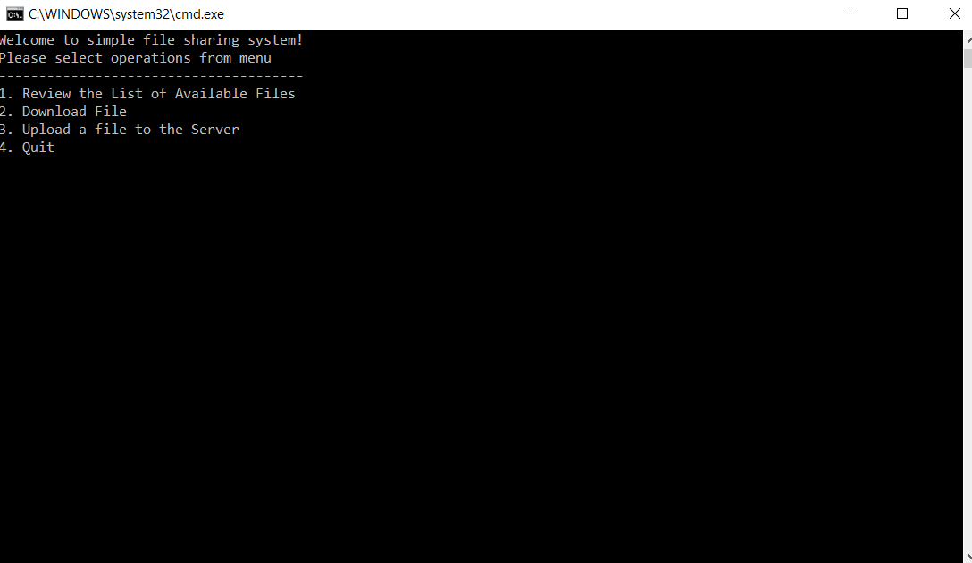

It has functions to take the user input and throws an error if user inputs an invalid option. Another function connect() is used to maintain a connection to the server. The getFileList() function requests the server side to send a list of files available to download while getFileListFromClient() locally retrieves the filenames from the client folder .
The 2 functions SelectUploadfile() and SelectDownloadFile() both retrieve the list of filenames and output a single file to be processed for download or upload.
The 2 functions downloadFile() and uploadFile() both accept a filename, establish a connection to the server and then perform the required download or upload.
The Start() function contains the main logic of the program. It accepts a selection from the menu displayed until the user terminates the program.

Test
So, this section just involves the testing of our socket program.
- First, we test the list file feature. The program shows us four options.: show files for download, download a specific file, upload a file to a server and quit.
- On selecting 1. We see a list of files from the server specified folder,

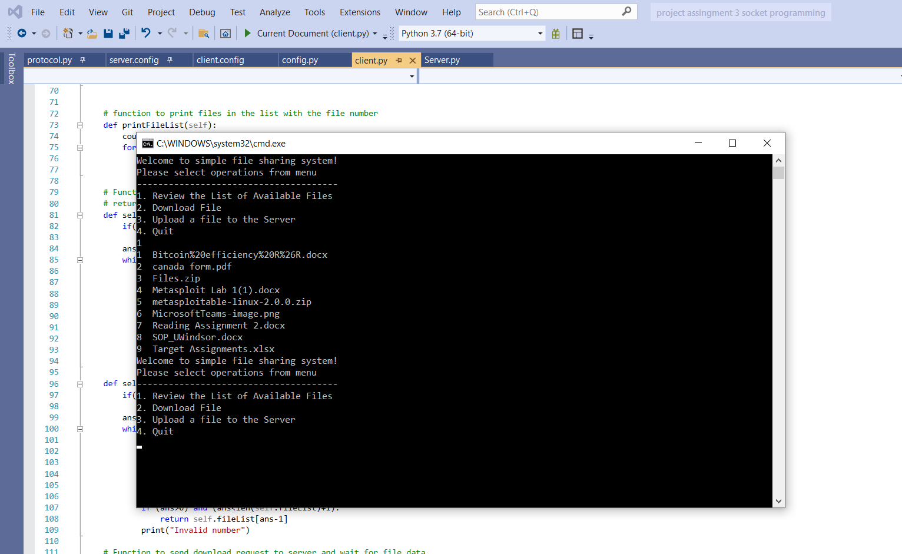

- Selecting option 2 it shows us the file names available to download and a number in front of it to make the selection process easier
- . Once we select the number, we can see that the file is downloaded to the folder mentioned in the client.config file. (CLIENT FILES folder in our case).
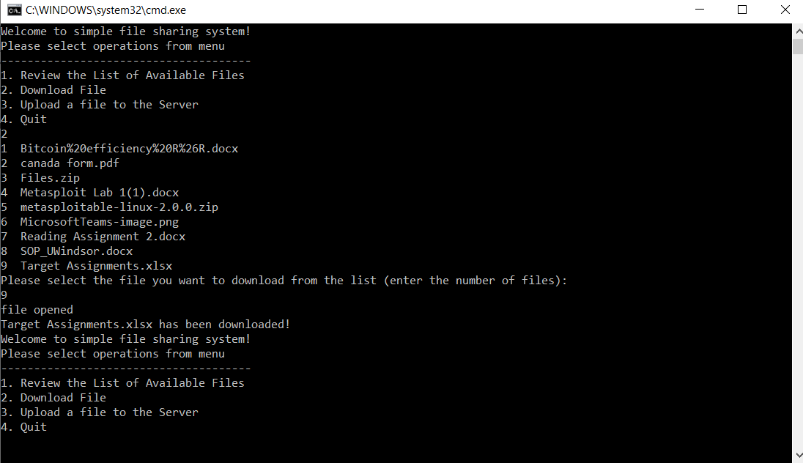
- Then we move on to option 3 which is the upload file to the server option. On pressing 3 we can see the names of the files we have on the client side with a number in front of the filenames to upload to the server.
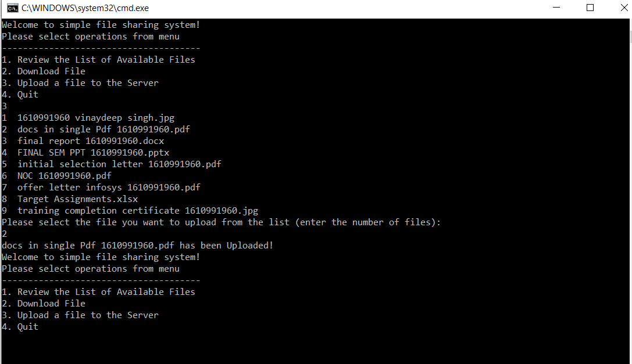
As we can see the files are now uploaded to the server side.
- Lastly, we can select option 4 to quit the program if we desire.

user manual
- All our files should be in the same directory to run the server properly.
- In our case we are running the Client and Server on the same machine. So, to change the Client and Server folders for an individual’s need, just open the client.config file and change the Field DOWNLOAD= path to any path the user wants as the client folder. We can also change the port number for the client and server to any port number of our convenience.
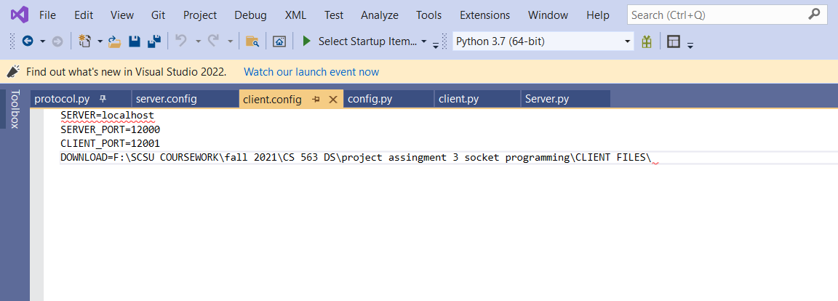
- For the server side. Open the server.config file and edit the PATH field to any folder of an individual’s choice. We also must change the port number to match the one in client.config file to run the server.
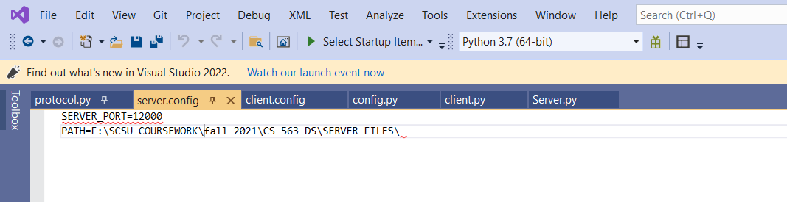
- In the test environment ,RUN THE SERVER FIRST as all requests are passed through the server. Also keep in mind that there could be only one Instance of a server running on one port else we will encounter an error.
- Run the client file. On the client side:
- Select option 1 for list of downloadable files. This will show the files in the directory we mentioned on the server side.
- Select option 2 to download a specific file. The program returns a list of files with numbers to help ease the selection process and avoid errors. Enter the number of the filename you want to download. The file will now be downloaded to the folder mentioned on the client side.
- Select option 3 to upload a file to the server. On pressing 3 the program gives a list of file names to select uploading to the server. Select a number next to the filename to upload that file to the server-side folder.
- Select option 4 to quit the program.

Acknowledgment
The author would like to thank Dr. Wu Hao ( Southern Connecticut state university) for giving me an opportunity to learn about socket programming and providing the sufficient resources and materials to do so.

References

- [5]"Socket Programming in Python - GeeksforGeeks", GeeksforGeeks, 2021. [Online]. Available: https://www.geeksforgeeks.org/socket-programming-python/. [Accessed: 16- Nov- 2021].
- "Python - Network Programming", Tutorialspoint.com, 2021. [Online]. Available: https://www.tutorialspoint.com/python/python_networking.htm. [Accessed: 16- Nov- 2021].

